Ammar Ahmed BDS2B2
20L-0961

Lab 13 Tasks
Task 1
Synchrous Up Counter
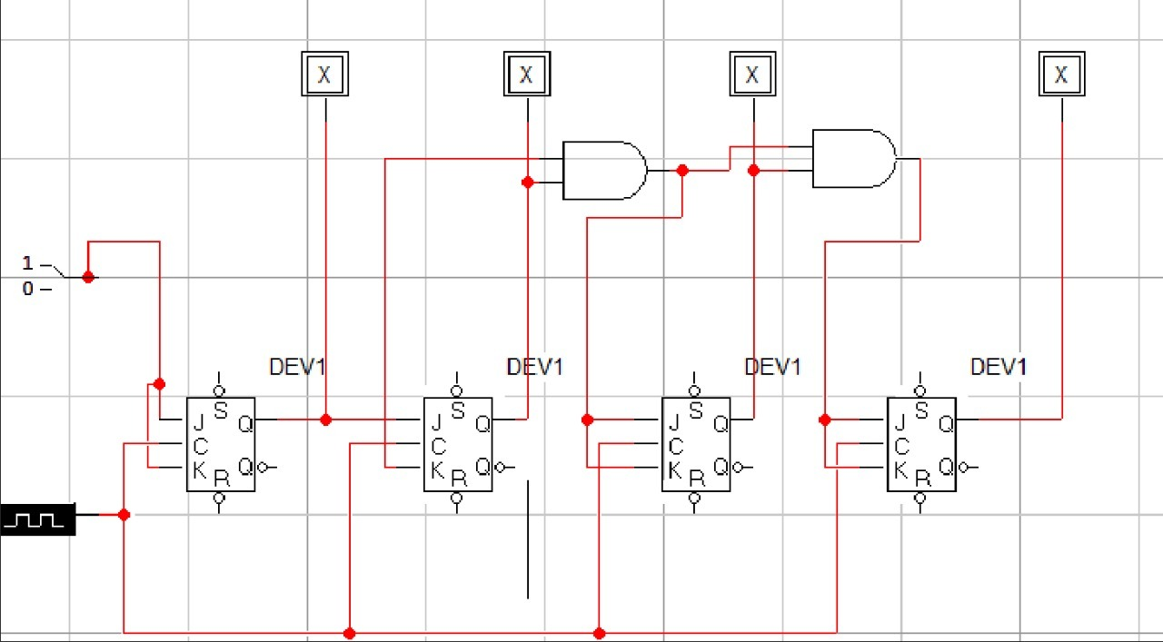

Task 2
Shift register with D flip-flops and 4 to 1 muxes
